Q: How many bits might be required for encoding the message “abracadabra”?

*Solution:

***- Table of sorted frequency:***

|  |  |
| --- | --- |
| Character | Frequency |
| c | 1 |
| d | 1 |
| r | 2 |
| b | 2 |
| a | 5 |

***- Huffman tree:***

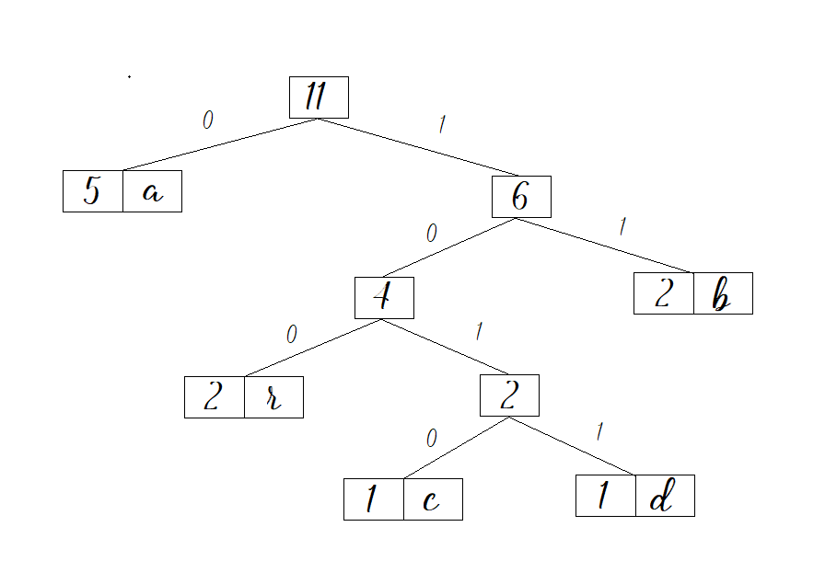

***- Codes:***

|  |  |  |  |
| --- | --- | --- | --- |
| Character | Frequency | Codes | Code length |
| c | 1 | 1010 | 4 |
| d | 1 | 1011 | 4 |
| r | 2 | 100 | 3 |
| b | 2 | 11 | 2 |
| a | 5 | 0 | 1 |

***- Total number of bits:***

= freq(c) * codelength(c) + freq(d) * codelength(d) + freq(r) * codelength(r) + freq(b) * codelength(b) + freq(a) * codelength(a)

= 1*4 + 1*4 + 2*3 + 2*2 + 5*1 = 23

***- Average bits per character:***

Total number of bits required

Total number of characters

= 23/5 = 4.6